3C) COST ACCOUNTING
Terminology, Fixed, Variable and Semi-variable costs

Cost accounting is a process of collecting, recording, classifying, analyzing, summarizing, allocating and evaluating various alternative courses of action to control the cost. Its goal is to advise the management on the most appropriate course of action based on the cost efficiency and capability. Cost accounting provides the detailed cost information that management needs to control current operations and plan for the future.

Since managers are making decisions only for their own organization, there is no need for the information to be comparable to similar information from other organizations. Instead, information must be relevant for a particular environment. Cost accounting information is commonly used in financial accounting information, but its primary function is for use by managers to facilitate making decisions.

Unlike the accounting systems that help in the preparation of financial reports periodically, the cost accounting systems and reports are not subject to rules and standards like the Generally Accepted Accounting Principles (GAAP). As a result, there is wide variety in the cost accounting systems of the different companies and sometimes even in different parts of the same company or organization.

All types of businesses, whether service, manufacturing or trading, require cost accounting to track their activities. Cost accounting has long been used to help managers understand the costs of running a business. Modern cost accounting originated during the industrial revolution, when the complexities of running a large scale business led to the development of systems for recording and tracking costs to help business owners and managers make decisions.
In the early industrial age, most of the costs incurred by a business were what modern accountants call "variable costs" because they varied directly with the amount of production. Money was spent on labour, raw materials, power to run a factory, etc. in direct proportion to production. Managers could simply total the variable costs for a product and use this as a rough guide for decision-making processes.

Some costs tend to remain the same even during busy periods, unlike variable costs, which rise and fall with volume of work. Over time, these "fixed costs" have become more important to managers. Examples of fixed costs include the depreciation of plant and equipment, and the cost of departments such as maintenance, tooling, production control, purchasing, quality control, storage and handling, plant supervision and engineering. In the early nineteenth century, these costs were of little importance to most businesses. However, with the growth of railroads, steel and large scale manufacturing, by the late nineteenth century these costs were often more important than the variable cost of a product, and allocating them to a broad range of products led to bad decision making. Managers must understand fixed costs in order to make decisions about products and pricing.
For example: A company produced railway coaches and had only one product. To make each coach, the company needed to purchase $60 of raw materials and components, and pay 6 labourers $40 each. Therefore, total variable cost for each coach was $300. Knowing that making a coach required spending $300, managers knew they couldn't sell below that price without losing money on each coach. Any price above $300 became a contribution to the fixed costs of the company. If the fixed costs were, say, $1000 per month for rent, insurance and owner's salary, the company could therefore sell 5 coaches per month for a total of $3000 (priced at $600 each), or 10 coaches for a total of $4500 (priced at $450 each), and make a profit of $500 in both cases.
Types of cost accounting
The following are different cost accounting approaches :
- Standard cost accounting
- Lean accounting
- Activity-based costing
- Resource consumption accounting
- Throughput accounting
- Life cycle costing
- Environmental accounting
- Target costing

Elements of cost - Basic cost elements are :
1) Materials - Material is a very important part of business - Direct material / Indirect material
2) Labour - Direct labour / Indirect labour
3) Overhead Expenses - Variable / Fixed
(i) Production or works overheads - Factory Staff
(ii) Administration overheads - Office Staff
(iii) Selling overheads - Catalogues, Advertising, Exhibitions, Sales
Staff Costs, Sale Promotional Activities.
(iv) Distribution overheads
(v) Maintenance & Repair - Office equipment / Factory machinery
(vi) Supplies
(vii) Utilities – Gas, Electricity, Water Rates
(viii) Other Variable Expenses
(ix) Salaries - Wages, Perks & Allowances, PF, Retirement
benefits, Pensions etc.
(x) Occupancy – Rent of the premises
(xi) Depreciation of Machinery / Office Equipment
(xii) Other Fixed Expenses

Classification of costs
(i) By Element
(ii) By Nature or Traceability
(iii) By Functions
(iv) By Behaviour
(v) By controllability
(vi) By normality
(vii) By Time
(viii) By Decision making Costs
(ix) Marginal costs
(x) Differential costs
(xi) Opportunity costs
(xii) Relevant cost
(xiii) Replacement cost
(xiv) Shutdown cost
(xv) Capacity cost
(xvi) Sunken cost
(xvii) Other costs

(In some companies, machine cost is segregated from overhead and reported as a separate element)
Classification of costs : Classification of cost means, the grouping of costs according to their common characteristics. The important ways of classification of costs are -
(i) By Element : There are three elements of costing i.e. Material, Labour and Expenses.
(ii) By Nature or Traceability : Direct Costs and Indirect costs. Direct Costs are Directly attributable / traceable to Cost object. Direct costs are assigned to Cost Object. Indirect Costs are not directly attributable / traceable to Cost Object. Indirect costs are allocated or apportioned to cost objects.
(iii) By Functions : Production, Administration, Selling and Distribution, R&D.
(iv) By Behaviour : Fixed, Variable, Semi-Variable. Costs are classified according to their behaviour in relation to change in relation to production volume within given period of time. Fixed Costs remain fixed irrespective of changes in the production volume in given period of time. Variable costs change according to volume of production. Semi-variable costs are partly fixed and partly variable.
(v) By controllability : controllable, uncontrollable costs. Controllable costs are those which can be controlled or influenced by a conscious management action. Uncontrollable costs cannot be controlled or influenced by a conscious management action.
(vi) By normality : normal costs and abnormal costs. Normal costs arise during routine day-to-day business operations. Abnormal costs arise because of any abnormal activity or event not part of routine business operations. E.g. costs arising of floods, riots, accidents etc.
(vii) By Time : Historical costs and predetermined costs. Historical costs are costs incurred in the past. Predetermined costs are computed in advance on basis of factors affecting cost elements. Example: Standard Costs.
(viii) By Decision making Costs : These costs are used for managerial decision making.
(ix) Marginal costs : Marginal cost is the change in the aggregate costs due to change in the volume of output by one unit.
(x) Differential costs : This cost is the difference in total cost that will arise from the selection of one alternative to the other.
(xi) Opportunity costs : It is the value of benefit sacrificed in favour of an alternative course of action.
(xii) Relevant cost : The relevant cost is a cost which is relevant in various decisions of management.
(xiii) Replacement cost : This cost is the cost at which existing items of material or fixed assets can be replaced. Thus this is the cost of replacing existing assets at present or at a future date.
(xiv) Shutdown cost : These costs are the costs which are incurred if the operations are shut down and they will disappear if the operations are continued.
(xv) Capacity cost : These costs are normally fixed costs. The cost incurred by a company for providing production, administration and selling and distribution capabilities in order to perform various functions.
(xvi) Sunken cost : Cost already incurred
(xvii) Other costs

Standard cost accounting : In modern cost account of recording historical costs was taken further, by allocating the company's fixed costs over a given period of time to the items produced during that period, and recording the result as the total cost of production. This allowed the full cost of products that were not sold in the period they were produced to be recorded in inventory using a variety of complex accounting methods, which was consistent with the principles of GAAP (Generally Accepted Accounting Principles). It also essentially enabled managers to ignore the fixed costs, and look at the results of each period in relation to the "standard cost" for any given product.
For example: if the railway coach company normally produced 40 coaches per month, and the fixed costs were still $1000/month, then each coach could be said to incur an Operating Cost/overhead of $25 =($1000 / 40). Adding this to the variable costs of $300 per coach produced a full cost of $325 per coach.

This method tended to slightly distort the resulting unit cost, but in mass-production industries that made one product line, and where the fixed costs were relatively low, the distortion was very minor.
For example: if the railway coach company made 100 coaches one month, then the unit cost would become $310 per coach ($300 + ($1000 / 100)). If the next month the company made 50 coaches, then the unit cost = $320 per coach ($300 + ($1000 / 50)), a relatively minor difference.

An important part of standard cost accounting is a variance analysis, which breaks down the variation between actual cost and standard costs into various components (volume variation, material cost variation, labor cost variation, etc.) so managers can understand why costs were different from what was planned and take appropriate action to correct the situation.

The development of throughput accounting : As business became more complex and began producing a greater variety of products, the use of cost accounting to make decisions to maximize profitability came into question. Management circles became increasingly aware of the Theory of Constraints in the 1980s, and began to understand that "every production process has a limiting factor" somewhere in the chain of production. As business management learned to identify the constraints, they increasingly adopted throughput accounting to manage them and "maximize the throughput dollars" (or other currency) from each unit of constrained resource. Throughput accounting aims to make the best use of scarce resources(bottle neck) in a (JIT) Just in time environment.
Mathematical formula : Throughput = Sales – Totally Variable Costs
Throughput Accounting Ratio = Return / Factory Hours

Activity-based costing : Activity-based costing (ABC) is a system for assigning costs to products based on the activities they require. In this case, activities are those regular actions performed inside a company. “Talking with customer regarding invoice questions” is an example of an activity inside most companies.

Companies may be moved to adopt ABC by a need to improve costing accuracy, that is, understand better the true costs and profitability of individual products, services, or initiatives. ABC gets closer to true costs in these areas by turning many costs that standard cost accounting views as indirect costs essentially into direct costs. By contrast, standard cost accounting typically determines so-called indirect and overhead costs simply as a percentage of certain direct costs, which may or may not reflect actual resource usage for individual items.

Under ABC, accountants assign 100% of each employee's time to the different activities performed inside a company (many will use surveys to have the workers themselves assign their time to the different activities). The accountant then can determine the total cost spent on each activity by summing up the percentage of each worker's salary spent on that activity.

A company can use the resulting activity cost data to determine where to focus their operational improvements. For example, a job-based manufacturer may find that a high percentage of its workers are spending their time trying to figure out a hastily written customer order. Via (ABC) Activity based costing, the accountants now have a currency amount pegged to the activity of "Researching Customer Work Order Specifications". Senior Mgmt can now decide how much focus or money to budget for resolving this process deficiency. Activity-based management includes (but is not restricted to) the use of activity-based costing to manage a business.
While (ABC) Activity based costing may be able to pinpoint the cost of each activity and resources into the ultimate product, the process could be tedious, costly and subject to errors.

As it is a tool for a more accurate way of allocating fixed costs into product, these fixed costs do not vary according to each month's production volume. For example, an elimination of one product would not eliminate the overhead or even direct labor cost assigned to it.Activity based costing (ABC) better identifies product costing in the long run, but may not be too helpful in day-to-day decision-making.

Integrating EVA and Process Based Costing : Recently, Mocciaro Li Destri, Picone & Minà (2012) proposed a performance and cost measurement system that integrates the Economic Value Added criteria with Process Based Costing (PBC). The EVA-PBC methodology allows us to implement the EVA management logic not only at the firm level, but also at lower levels of the organization. EVA-PBC methodology plays an interesting role in bringing strategy back into financial performance measures.

Lean accounting : Lean accounting has developed in recent years to provide the accounting, control, and measurement methods supporting lean manufacturing and other applications of lean thinking such as healthcare, construction, insurance, banking, education, government, and other industries.

There are two main thrusts for Lean Accounting. The first is the application of lean methods to the company's accounting, control, and measurement processes. This is not different from applying lean methods to any other processes. The objective is to eliminate waste, free up capacity, speed up the process, eliminate errors & defects, and make the process clear and understandable. The second (and more important) thrust of Lean Accounting is to fundamentally change the accounting, control, and measurement processes so they motivate lean change & improvement, provide information that is suitable for control and decision-making, provide an understanding of customer value, correctly assess the financial impact of lean improvement, and are themselves simple, visual, and low-waste. Lean Accounting does not require the traditional management accounting methods like standard costing, activity-based costing, variance reporting, cost-plus pricing, complex transactional control systems, and untimely & confusing financial reports. These are replaced by:
• lean-focused performance measurements
• simple summary direct costing of the value streams
• decision-making and reporting using a box score
• financial reports that are timely and presented in "plain English" that everyone can understand
• radical simplification and elimination of transactional control systems by eliminating the need for them
• driving lean changes from a deep understanding of the value created for the customers
• eliminating traditional budgeting through monthly sales, operations, and financial planning processes (SOFP)
• value-based pricing
• correct understanding of the financial impact of lean change

As an organization becomes more mature with lean thinking and methods, they recognize that the combined methods of lean accounting in fact creates a lean management system (LMS) designed to provide the planning, the operational and financial reporting, and the motivation for change required to prosper the company's on-going lean transformation.

Cost-Volume-Profit (CVP) analysis is the systematic examination of the relationship between selling prices, sales, production volumes, costs, expenses and profits. This analysis provides very useful information for decision-making in the management of a company. For example, the analysis can be used in establishing sales prices, in the product mix selection to sell, in the decision to choose marketing strategies, and in the analysis of the impact on profits by changes in costs. In the current environment of business, a business administration must act and take decisions in a fast and accurate manner. As a result, the importance of cost-volume-profit is still increasing as time passes.
CONTRIBUTION MARGIN : A relationship between the cost, volume and profit is the contribution margin. The contribution margin is the revenue excess from sales over variable costs. The concept of contribution margin is particularly useful in the planning of business because it gives an insight into the potential profits that a business can generate. The following chart shows the income statement of a company X, which has been prepared to show its contribution margin :

Sales Rs. 1,000,000
(-) Variable Costs Rs. 600,000
Contribution Rs. 400,000
(-) Fixed Costs Rs. 300,000
Income from Operations Rs. 100,000

CONTRIBUTION MARGIN RATIO : The contribution margin can also be expressed as a percentage. The contribution margin ratio, which is sometimes called the profit-volume ratio, indicates the percentage of each sales dollar available to cover fixed costs and to provide operating revenue. For the company Fusion, Inc. the contribution margin ratio is 40%, which is computed as follows :

Contribution Margin Ratio = (Sales – Variable Costrs) / Sales

The contribution margin ratio measures the effect on operating income of an increase or a decrease in sales volume. For example, assume that the management of Fusion, Inc. is studying the effect of adding $80,000 in sales orders. Multiplying the contribution margin ratio (40%) by the change in sales volume ($80,000) indicates that operating income will increase $32,000 if additional orders are obtained. To validate this analysis the table below shows the income statement of the company including additional orders:
Sales Rs. 1,080,000
(-) Variable Costs Rs. 648,000 (1,080,000 x 60%)
Contribution Rs. 432,000 (1,080,000 x 40%)
(-) Fixed Costs Rs. 300,000
Income from Operations Rs. 132,000

Variable costs as a percentage of sales are equal to 100% minus the contribution margin ratio. Thus, in the above income statement, the variable costs are 60% (100% - 40%) of sales, or $648,000 ($1,080,000 x 60%). The total contribution margin $432,000, can also be computed directly by multiplying the sales by the contribution margin ratio ($1,080,000 x 40%).

The CEO's salary is likey to rise in line with general wage increases, but it remains a fixed cost. By way of contrast, variable costs increase or decrease in line with learner numbers. Definition. A variable cost is any expenditure that varies in direct proportion to a change in the level of productive activity.

Fixed, Variable and Semi-Variabable Costs :
In cases where expenditure does NOT increase or decrease with the level of productive activity, then this is categorised as a Fixed Cost. For example, (i) regardless of whether an institution has a hundred registered students or a hundred thousand, it needs to employ a chief executive officer (CEO) or director. Although the duties of the post and the salary on offer would very likely be different in the two situations, the salary of the CEO is considered a fixed cost. However, just because some item of expenditure is categorised as a fixed cost, this doesn't mean it can't change from year to year. The CEO's salary is likey to rise in line with general wage increases, but it remains a fixed cost. (ii) Land, Machinery and other Capital expenditures for a Production organisation is FC.

A Variable Cost is any expenditure that varies in direct proportion to a change in the level of productive activity.
Expenditure for printing study materials is a good example of a variable cost. For each additional student enrolled for a course, extra expenditure is incurred.

Some costs seem stable for a particular level of activity, but suddenly increase with a significant increase in student numbers.
A cost that changes, in total monetary value, with the change in the level of activity is called variable cost. A common example of variable cost is direct materials cost. More the production volume the more will be the requirement of raw material.

The term Semi-Variable Cost refers to expenditure which remains fixed within a particular level of productive activity, which is referred to as the range. If the level exceeds this range, then additional costs will be incurred.

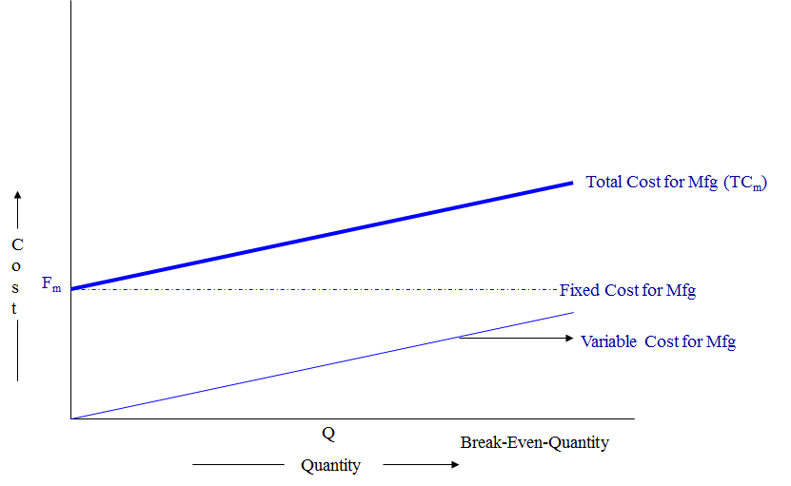

For example, most institutions have policies regarding the maximum number of students who can be accommodated in a class group for face-to-face tutorials. When student numbers exceed the maximum, then a second class group is formed, necessitating the employment of another tutor (or additional hours for the same part-time tutor).

This exercise highlights the fact that, while many costs appear to be fixed at first glance, they are really semi-variable. Take, for example, the salary of the institution’s CEO or Director. When student numbers are low, the CEO will most likely have responsibility for many tasks related to the supervision of staff and the day-to-day running of the institution. However, if student numbers grow dramatically, it is often necessary to buy in specialised services or employ extra managerial or professional staff to take over some of these duties. Thus, even though the institution still has only one CEO, the job that he or she originally carried out has been split among a number of additional employees, with an accompanying increase in costs.
Variable, fixed and mixed (semi-variable) costs : As the level of business activities changes, some costs change while others do not. The response of a cost to a change in business activity is known as cost behaviour. Managers should be able to predict the behavior of a particular cost in response to a change in particular business activity. For this purpose, costs are classified as variable, fixed and mixed costs.

Direct costs and indirect costs : Costs may be classified as direct costs or indirect costs. The purpose of this classification is to assign costs to cost objects. Cost object means any thing about which cost information is collected. Some examples of cost objects are products, departments, customers, plant, a territory, a product line and research and development activities of the business etc.
A brief explanation of direct costs and indirect costs are given below -

Direct cost : A cost that is easily traceable to a particular cost object is known as direct cost. The use of the term “direct cost” is not limited to direct materials and direct labour. Every cost that can be easily and conveniently traced to a particular product, customer, branch, plant or any other cost object is a direct cost. For example, if Bata shoes company wants to assign costs to all the branches in Pakistan, then the salary of the manager of Islamabad branch would be a direct cost of that branch.
Indirect cost : A cost that is not easily traceable to a particular cost object is called indirect cost. For example, a clothing factory produces different varieties of cloths. The salary of the manager would be an indirect cost because it is caused by all the varieties and is not easily traceable to a particular variety. The Rafhan Maize Products company produces a large number of products by processing tones of corn every year. The salary of the factory manager is an indirect cost for the products because it is not caused by a particular product.

The costs that are caused by a number of cost objects but cannot be traced to a particular cost object is known as common cost. In our examples, the salaries of the managers of clothing factory and Rafhan maize products are common costs.
When we say direct or indirect cost, we mean that it is direct or indirect with respect to a particular cost object. A cost may be direct for one cost object but indirect for another. For example, National Food Products Co. has a number of branches in Pakistan. Each branch sell a variety of food products. The salary of the manager of Karachi branch would be an indirect cost of a particular product but direct cost of the branch as a whole.

Differential, opportunity and sunk costs : Costs may be classified as differential cost, opportunity cost and sunk cost. This classification is made for decision making purposes. Explanation and examples of differential, opportunity and sunk costs are given below -
Differential cost : The work of managers includes comparison of costs and revenues of different alternatives. Differential cost (also known as incremental cost) is the difference in cost of two alternatives. For example, if the cost of alternative A is $10,000 per year and the cost of alternative B is $8,000 per year. The difference of $2,000 would be differential cost. The differential cost can be a fixed cost or variable cost.

Similarly the difference in revenue of two alternatives is known as differential revenue. For example, if alternative A’s revenue is $15,000 and alternative B’s revenue is $10,000. The difference of $5,000 would be differential revenue.

When different revenue generating alternatives are compared, the differential cost as well as differential revenues associated with each alternative is taken into account.

The terms “differential cost” and “differential revenue” used in managerial accounting are similar to the terms “marginal cost” and “marginal revenue” used in economics.Example – computation of differential cost, differential revenues and differential net operating income:

The management of Galaxy company has two alternatives to choose from. Compute differential revenue, differential cost and differential net operating income from the information of two alternatives given below
In the above example, total differential revenue is $200,000 (1,600,000 – 1,400,000), differential cost is $130,000 (1,240,000 – 1,110,000) and differential net operating income is $70,000 ($360,000 – $290,000).
If a decision is made on the basis of above computations, alternative 2 would be selected because it promises to generate more net operating income.

Opportunity cost : Unlike other types of cost, opportunity cost does not require the payment of cash or its equivalent. It is a potential benefit or income that is given up as a result of selecting an alternative over another. For example, You have a job in a company that pays you $25,000 per year. For a better future, you want to get a Master’s degree but cannot continue your job while studying. If you decide to give up your job and return to school to earn a Master’s degree, you would not receive $25,000. Your opportunity cost would be $25,000.
Almost every alternative has an opportunity cost. It is not entered in the accounting records but must be considered while making decisions.

Sunk cost : The costs that have already been incurred and cannot be changed by any decision are known as sunk costs. For example, a company purchased a machine several years ago. Due to change in fashion in several years, the products produced by the machine cannot be sold to customers. Therefore the machine is now useless or obsolete. The price originally paid to purchase the machine cannot be recovered by any action and is therefore a sunk cost.

These costs should not be taken into account while making any decision because no action can revers them.
Costs of quality or quality costs : Costs of quality or quality costs does not mean the use of expensive or very highly quality materials to manufacture a product. The term refers to the costs that are incurred to prevent, detect and remove defects from products. Quality costs are categorized into four main types. Theses are:
1. Prevention costs
2. Appraisal costs
3. Internal failure costs and
4. External failure costs.

These four types of quality costs are briefly explained below:
Prevention costs : It is much better to prevent defects rather than finding and removing them from products. The costs incurred to avoid or minimize the number of defects at first place are known as prevention costs. Some examples of prevention costs are improvement of manufacturing processes, workers training, quality engineering, statistical process control etc.

Appraisal costs : Appraisal costs (also known as inspection costs) are those cost that are incurred to identify defective products before they are shipped to customers. All costs associated with the activities that are performed during manufacturing processes to ensure required quality standards are also included in this category. Identification of defective products involve the maintaining a team of inspectors. It may be very costly for some organizations.

Internal failure costs : Internal failure costs are those costs that are incurred to remove defects from the products before shipping them to customers. Examples of internal failure costs include cost of rework, rejected products, scrap etc.

External failure costs : If defective products have been shipped to customers, external failure costs arise. External failure costs include warranties, replacements, lost sales because of bad reputation, payment for damages arising from the use of defective products etc. The shipment of defective products can dissatisfy customers, damage goodwill and reduce sales and profits.

More examples of quality costs -
Examples of prevention cost
• System development
• Quality engineering
• Quality training
• Quality circles
• Statistical process control
• Supervision of prevention
• Quality improvement projects
• Technical support to suppliers
• Quality data gathering, analysis and reporting
• Audit of the quality system

Examples of appraisal cost
• Test and inspection of incoming materials
• Final product testing and inspection
• Supplies used in testing and inspection
• Supervision of testing and inspecting activities
• Depreciation of test equipment
• Maintenance of test equipment
• Plant utilities in inspection area
• Field testing and appraisal at customer site

Examples of internal failure cost
• Net cost of scrap
• Net cost of spoilage
• Rework labor and overhead
• Reinspection of reworked products
• Disposal of defective products
• Down time caused by quality problems
• Analysis of the cause of defects in the production
• Retesting of reworked products
• Re-entering data because of keying
• Debugging software errors

Examples of external failure cost
• Cost of field servicing and handling complaints
• Warranty repairs and replacement costs
• Liability arising from defective products
• Lost sales arising from a reputation of poor quality
• Returns and allowances arising from quality problems
• Product recalls
• Repairs and replacements beyond the warranty period

The break-even point (BEP) or break-even level represents the sales amount - in either unit (quantity) or revenue (sales) terms - that is required to cover total costs, consisting of both fixed and variable costs to the company. Total profit at the break-even point is zero.

The break-even point (BEP) in economics, business, and specifically cost accounting, is the point at which total cost and total revenue are equal: there is no net loss or gain, and one has "broken even." A profit or a loss has not been made, although opportunity costs have been "paid", and capital has received the risk-adjusted, expected return. In short, all costs that needs to be paid are paid by the firm but the profit is equal to 0.

The break-even point (BEP) or break-even level represents the sales amount - in either unit (quantity) or revenue (sales) terms - that is required to cover total costs, consisting of both fixed and variable costs to the company. Total profit at the break-even point is zero. It is only possible for a firm to Break-even, if the dollar value of sales is higher than the variable cost per unit. This means that the selling price of the good needs to be higher than what the company purchased the good, or components of the good for, in order for them to cover the initial price they paid (variable costs). Once the break-even price has been surpassed, the company can start making a profit.
The break-even point is one of the most commonly used concepts of financial analysis and is not only limited to economic use, but can also be utilized by entrepreneurs, accountants, financial planners, managers and even marketers. Break-even points can be useful to all avenues of a business, as it allows employees to identify required outputs and work towards meeting these.

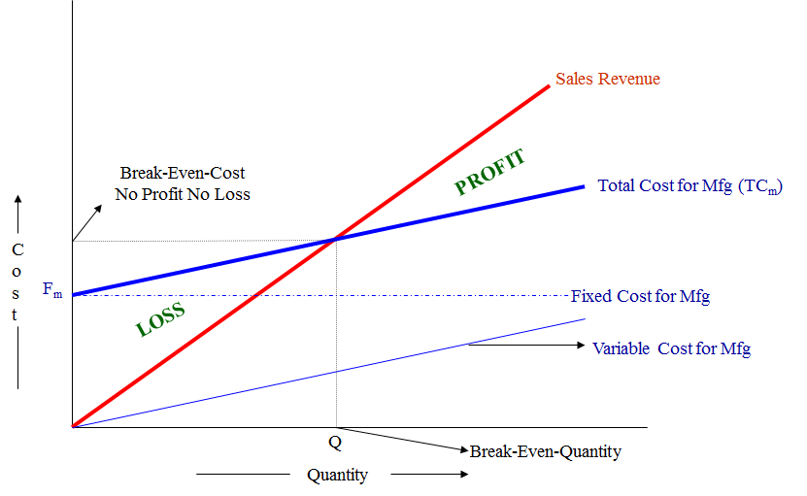
The Breakeven value is not a generic value and will vary dependent on the individual business. Some businesses may have a higher or lower breakeven point, however it is important that each business develop a break-even point calculation, as this will enable them to see the number of units they need to sell to cover their variable costs. Each sale will also make a contribution to the payment of fixed costs as well.

For example, a business that sells tables needs to make annual sales of 200 tables to break-even. At present the company is selling less than 200 tables and is therefore operating at a loss. As a business, they need to consider increasing the amount of tables that they are selling annually in order to make enough money to pay both their fixed and variable costs.

If the business does not think that they can sell the required amount of units, in order to ensure their future viability, they could consider doing the following options:

Try to reduce the fixed costs that they face. This could be done through a number or negotiations, such as reductions in rent, or through better management of bills or other costs faced by the business
1. Try to reduce variable costs, for example, finding a new supplier that sells tables thus reducing the amount paid for tables.
2. Increase the quantity of tables that they are selling.
Any of these options have the potential to reduce the break-even point. This means that the business would not need to sell as many tables as before, and would still be able to pay their fixed costs.

The main purpose of break-even analysis is to determine the minimum output that must be exceeded in order for a business to make profit. It also is a rough indicator of the earnings impact of a marketing activity. A firm is able to analyze their ideal levels of output and therefore be knowledgeable on the amount of sales and revenue they need to generate in order to meet and surpass the break-even point and ensure the survival of the business. If this level is not met, it often becomes difficult for the business to continue to operate and thus they may have to shut down their operations.

The break-even point is one of the simplest, yet least utilized analytical tools by a business’s management team. Identifying a breakeven point helps to provide a dynamic view of the relationships between sales, costs, and profits made. For example, expressing break-even sales as a percentage of actual sales can give managers a chance to understand when to expect to break even (by linking the percent to when in the week/month this percent of sales might occur).
The break-even point is a special case of Target Income Sales, where Target Income is 0 (breaking even). This is very important for financial analysis. Any sales made past the breakeven point can be considered profit (after all initial costs have been paid).

The break-even point is one of the simplest, yet least utilized analytical tools by a business’s management team. Identifying a breakeven point helps to provide a dynamic view of the relationships between sales, costs, and profits made. For example, expressing break-even sales as a percentage of actual sales can give managers a chance to understand when to expect to break even (by linking the percent to when in the week/month this percent of sales might occur).
The break-even point is a special case of Target Income Sales, where Target Income is 0 (breaking even). This is very important for financial analysis. Any sales made past the breakeven point can be considered profit (after all initial costs have been paid).

Break-even analysis can also provide data that can be useful to the marketing department of a business as well, as it provides financial goals to the business which can be passed down to marketers in order to try and increase sales.

Not only is the break-even analysis beneficial to the financial side of the business, but it can also provide a chance for operating businesses to see where they could re-structure or cut costs and get the optimum results out of the resources that they have. This may in the long term help the business become more effective and achieve higher returns. In many cases, if an entrepreneurial venture is seeking to get off of the ground and enter into a market it is advised that they formulate a break-even analysis to suggest to potential financial backers that the business has the potential to be viable and at what points.

In the linear Cost-Volume-Profit Analysis model (where marginal costs and marginal revenues are constant, among other assumptions), the break-even point (BEP) (in terms of Unit Sales (X)) can be directly computed in terms of Total Revenue (TR) and Total Costs (TC) as:
TR = TC
P x X = TFC + V x X
P x X - V x X = TFC
(P – V) x X = TFC
X = TFC / (P – V)
where:
TFC is Total Fixed Costs,
P is Unit Sale Price, and
V is Unit Variable Cost.

The quantity (P – V), is of interest in its own right, and is called the Unit Contribution Margin (C): it is the marginal profit per unit, or alternatively the portion of each sale that contributes to Fixed Costs. Thus the break-even point can be more simply computed as the point where Total Contribution = Total Fixed Cost:

Total Contribution = Total Fixed Cost
Unit Contribution x No. of Units = Total Fixed Cost
No. of Units = Total Fixed Costs / Unit Contribution

To calculate the break-even point in terms of revenue (a.k.a. currency units, a.k.a. sales proceeds) instead of Unit Sales (X), the above calculation can be multiplied by Price, or, equivalently, the Contribution Margin Ratio (Unit Contribution Margin over Price) can be calculated –

Break-even (in Sales) = Fixed Cost / (C / P)
R = C, Where R is revenue generated, C is cost incurred i.e. Fixed costs + Variable Costs or Q * P (Price per unit) = TFC + Q * VC (Price per unit), Q * P - Q * VC = TFC,
Q * (P - VC) = TFC,
or, Break Even Analysis Q = TFC/c/s ratio = Break Even

Margin of safety : Margin of safety represents the strength of the business. It enables a business to know what is the exact amount it has gained or lost and whether they are over or below the break-even point. In break-even analysis, margin of safety is the extent by which actual or projected sales exceed the break-even sales.
Margin of safety = (current output - breakeven output)
Margin of safety % = [(current output - breakeven output) × 100 /current output
When dealing with budgets you would instead replace "Current output" with "Budgeted output." If P/V ratio is given then profit/PV ratio.

Break-even analysis : By inserting different prices into the formula, you will obtain a number of break-even points, one for each possible price charged. If the firm changes the selling price for its product, from $2 to $2.30, in the example above, then it would have to sell only 1000/(2.3 - 0.6)= 589 units to break even, rather than 715.
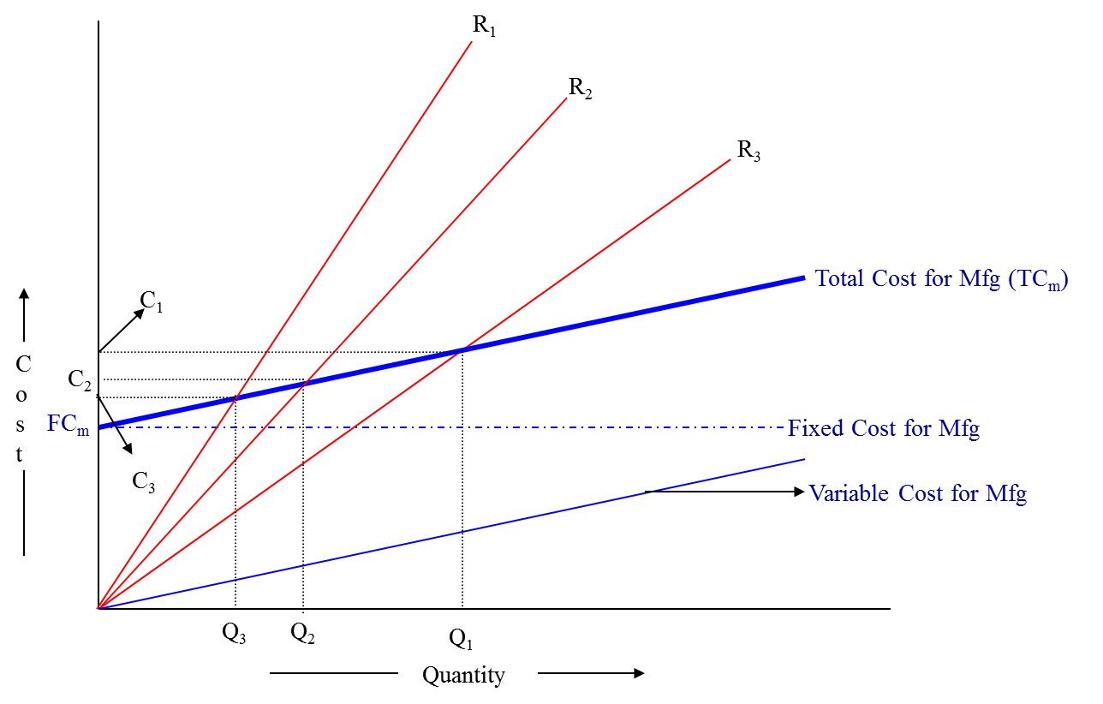

To make the results clearer, they can be graphed. To do this, you draw the total cost curve (TC in the diagram) which shows the total cost associated with each possible level of output, the fixed cost curve (FC) which shows the costs that do not vary with output level, and finally the various total revenue lines (R₁, R₂, and R₃) which show the total amount of revenue received at each output level, given the price you will be charging.

The break-even points (A, B, C) are the points of intersection between the total cost curve (TC) and a total revenue curve (R₁, R₂, or R₃). The break-even quantity at each selling price can be read off the horizontal axis and the break-even price at each selling price can be read off the vertical axis. The total cost, total revenue, and fixed cost curves can each be constructed with simple formula.

For example, the total revenue curve is simply the product of selling price times quantity for each output quantity. The data used in these formula come either from accounting records or from various estimation techniques such as regression analysis.
Limitations -
(i) Break-even analysis is only a supply-side (i.e., costs only) analysis, as it tells you nothing about what sales are actually likely to be for the product at these various prices.
(ii) It assumes that fixed costs (FC) are constant. Although this is true in the short run, an increase in the scale of production is likely to cause fixed costs to rise.
(iii) It assumes average variable costs are constant per unit of output, at least in the range of likely quantities of sales. (i.e., linearity).
(iv) It assumes that the quantity of goods produced is equal to the quantity of goods sold (i.e., there is no change in the quantity of goods held in inventory at the beginning of the period and the quantity of goods held in inventory at the end of the period).
(v) In multi-product companies, it assumes that the relative proportions of each product sold and produced are constant (i.e., the sales mix is constant).
(vi) A cost sheet is prepared to know the outcome and breakup of costs for a particular accounting period. Columnar form is most popular. Although cost sheets are prepared as per the requirements of the management, the information to be incorporated in a cost sheet should comprise of cost per unit and the total cost for the current period along with the cost per unit and the total cost of preceding period. Data of financial statement is used for preparation of cost sheet. Therefore, reconciliation of cost sheet and financial statement should be done on a regular interval.

